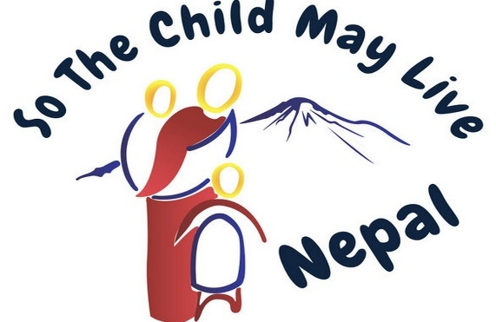

Saving children’s lives in Nepal

A WONDERFUL EVENING OF MUSIC

Friday 7 June, 6.30pm

Tayo Aluko Joanne & Alex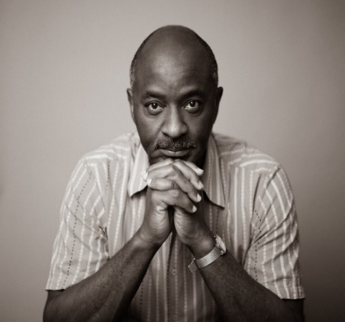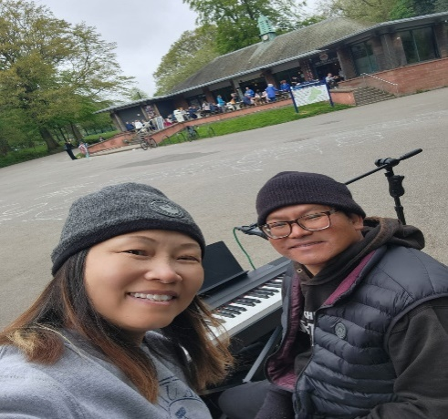

A great African singerSinger&Pianist from Hong Kong

and the Asylum Link Choir

Together with a short film made by two of our supporters about their first visit to Nepal

St Anthony of Padua Church Hall

Queens Drive

Liverpool L18 8BD

Entrance £15

Includes meal, teas and coffees

(bring your own drinks if you want to)

Tickets can be ordered from So the Child May Live,

address below, or pay at the door

So the Child May Live, 9 Bridgemere House, Mossley Hill Drive, Liverpool, L17 0ET

Tel: 0151-2813064, or 07711291458